Ray Omoregie

August 8th, 2020

CST-247

Activity 3

**Screenshot 1:**

**Screenshot 2:**

**Screenshot 3:**

**Screenshot 4:**

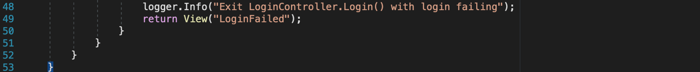

**Screenshot 5:**

**Screenshot 6:**

**Screenshot 7:**

**Screenshot 8:**

**Screenshot 9:**

**Screenshot 10:**

**Screenshot 11:**

**Screenshot 12:**

**Screenshot 13: A screenshot of a cell phone

Description automatically generated**

Here is the GitHib Link:

